Nat Baylon, Kyle Fritz, Tommy Tran

Part 1: Advising Webpage

Overall challenges we had:

The most challenging part of working on these webpages was getting every group member to agree on the deadlines we set for finishing the various pages. While in the end we roughly had the same amount of work, people had different ideas of when they wanted to complete their parts. This was frustrating at times, but we worked through it. It took a great push to get everything done on time. Nat (me) and Kyle were working hard on the project throughout the semester, but we had to really push Tommy to work and turn things in on github. He came through in the end though, and completed some crucial pages and did most of the styling, although he could have took more initiative.

In terms of the coding, a lot of the code came straight from Nat’s first project, but everyone had to brush up on the php time functions and sql, so we could all be in agreement and understanding of how to complete the pages/how all the pages work. Toward the end of the project, everyone was pretty proficient in php and sql, so we were able to work efficiently and break up the work more evenly.

We decided to have ‘demo’ as a session variable in index.php, so that we could demonstrate the project for the presentation, which occurs after the last day a student can sign up for advising. Otherwise, times would not be available for the advisor to select while we were demonstrating the project. So in demo mode, the times for selection are based around today, whereas when demo mode is off, the times are only for the specified date range in the project description.

Some other challenges were getting php and javascript to work in harmony, because it was a bit tricky combining them and getting to work at the same time. And when we all don’t have the newest version of a page, it’s hard to be sure that we build the other pages correctly. Communication is key.

Screen Captures/Walkthrough

1. Index Page

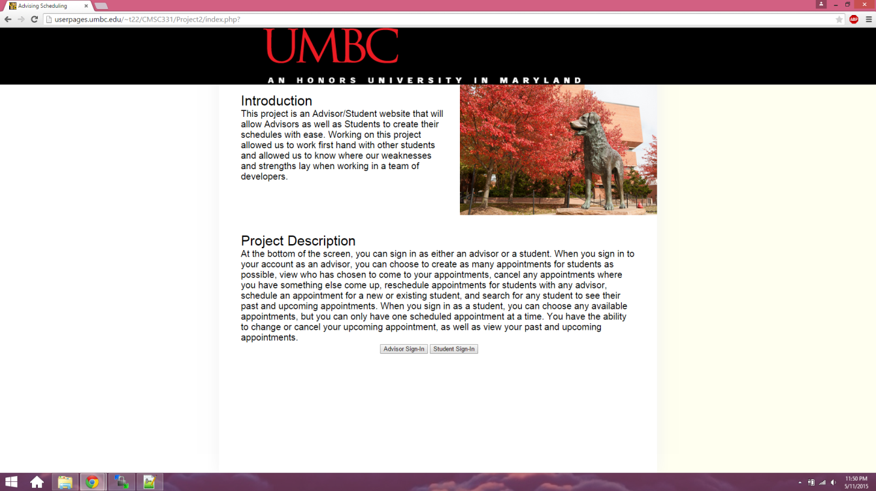

1. Student Signin

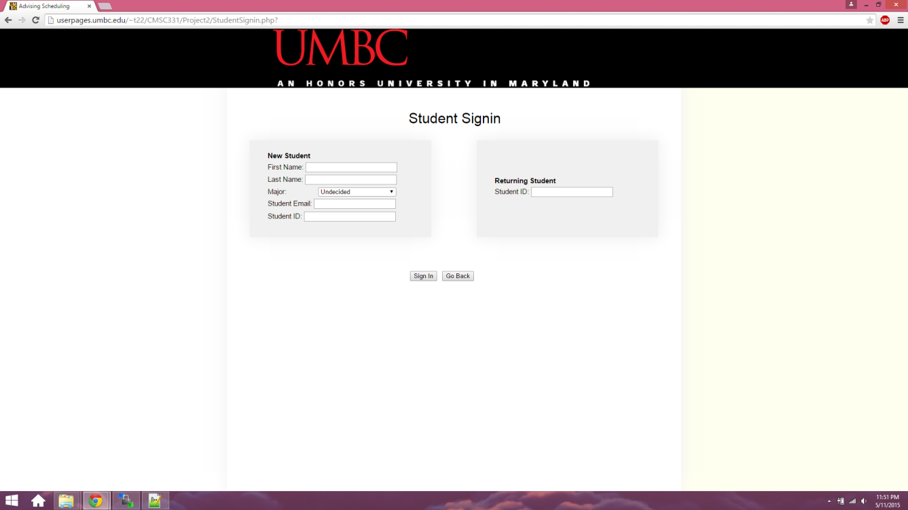

1. Student’s info filled in (invalid email)

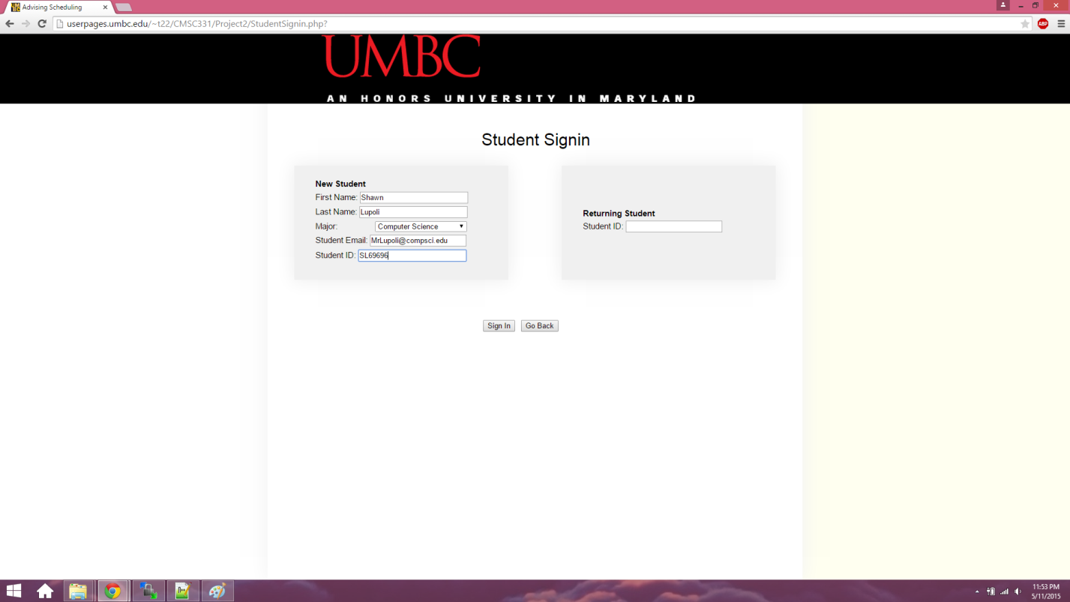

1. Example student signin error message

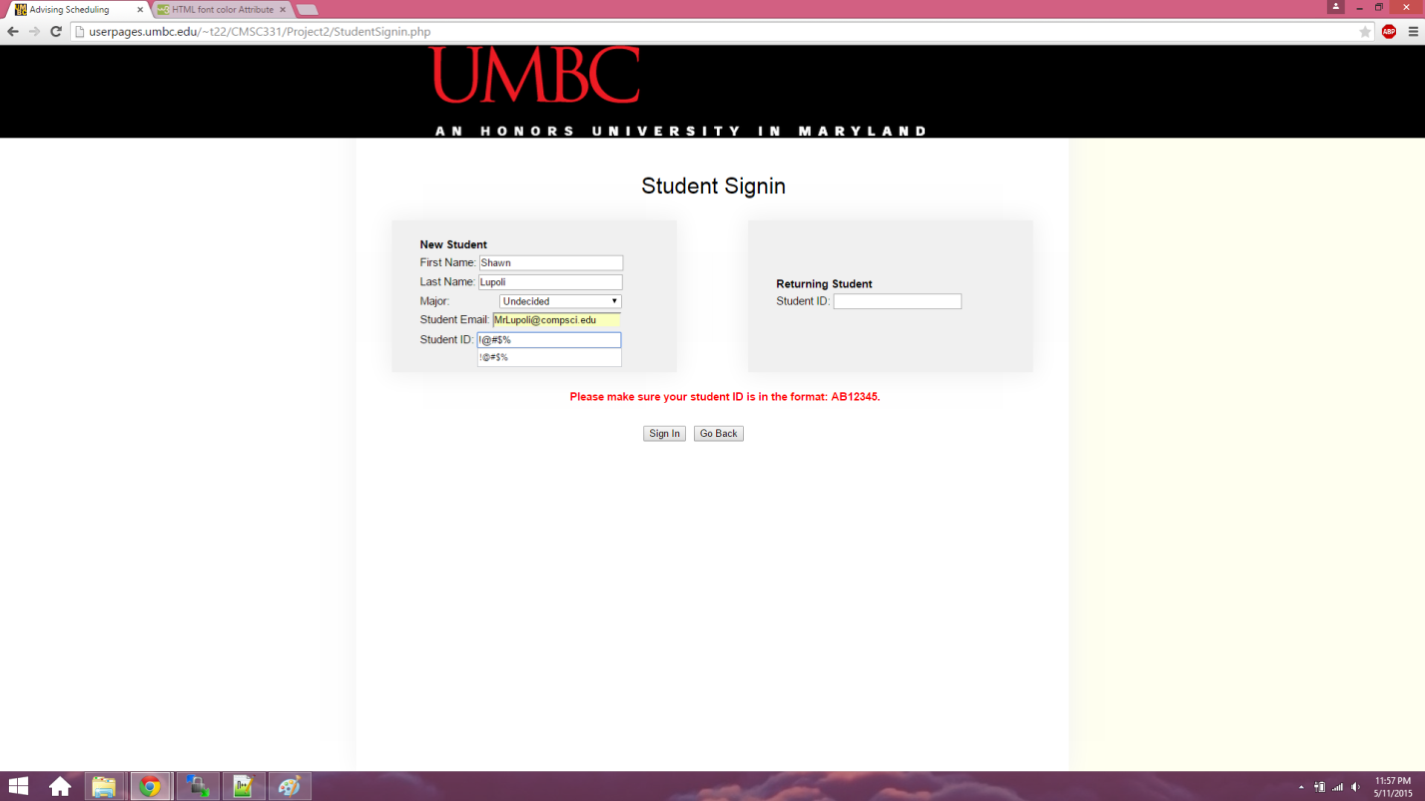

1. Info in both signin areas error

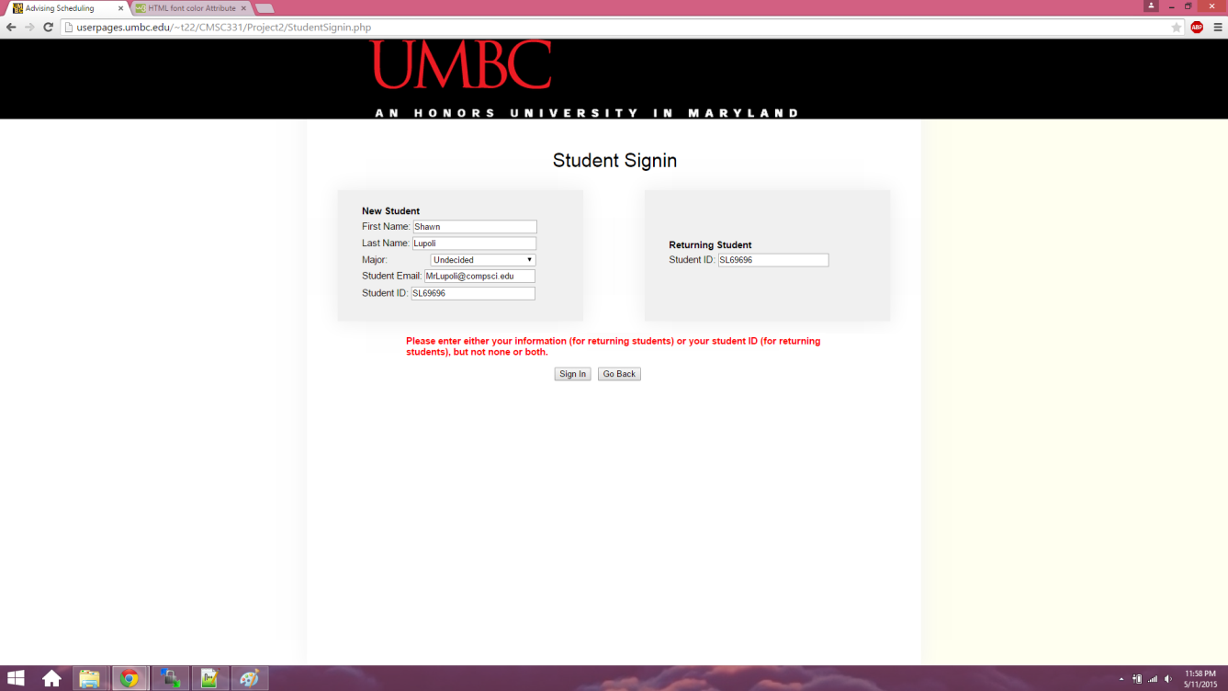

1. Student Options Page

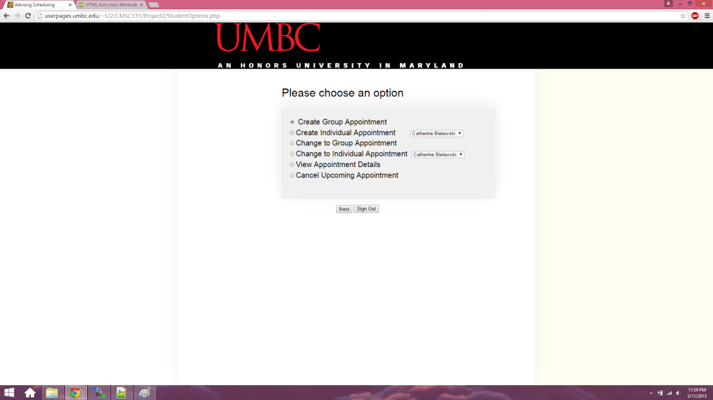

1. Student Create Appointment

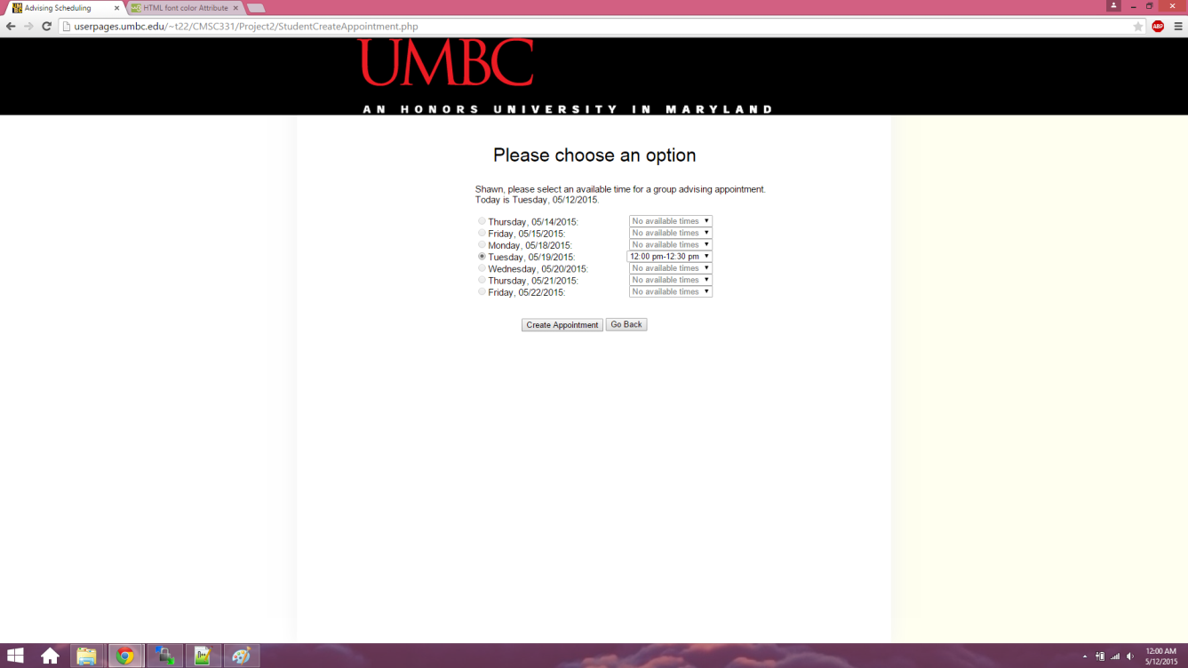

1. After Student Creates Appointment

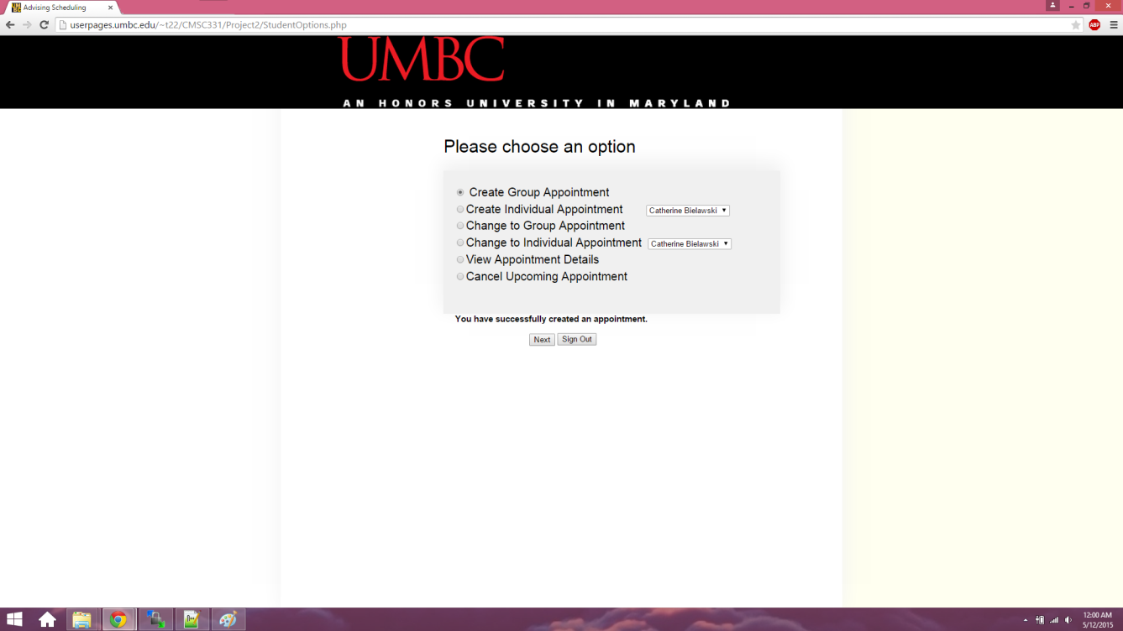

1. Student tries creating another appointment

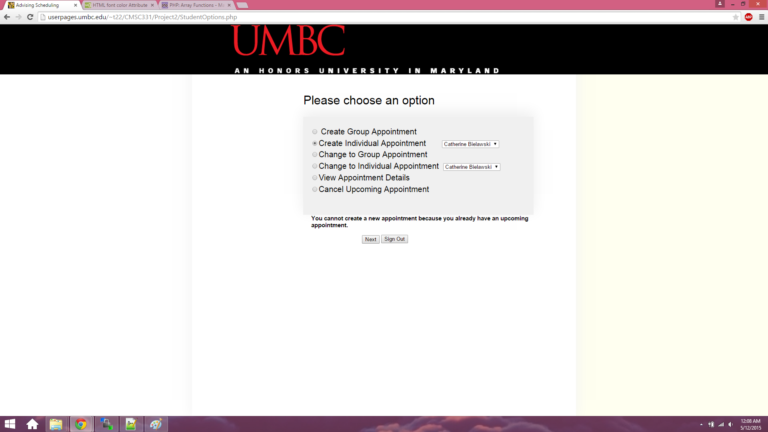

1. Student Changes their appointment to group appointment

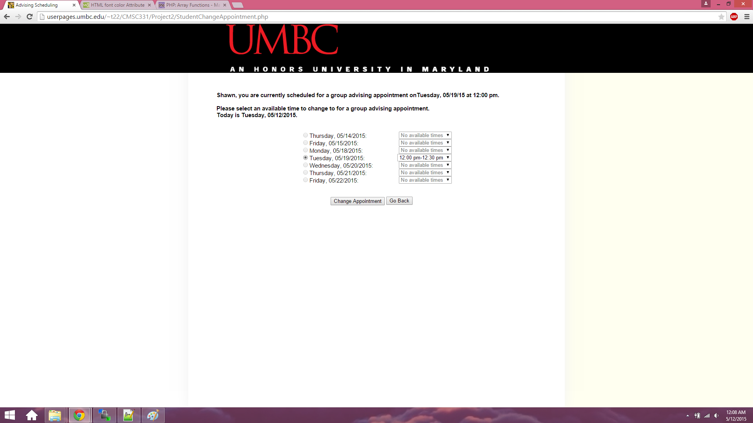

1. After student changes their appointment

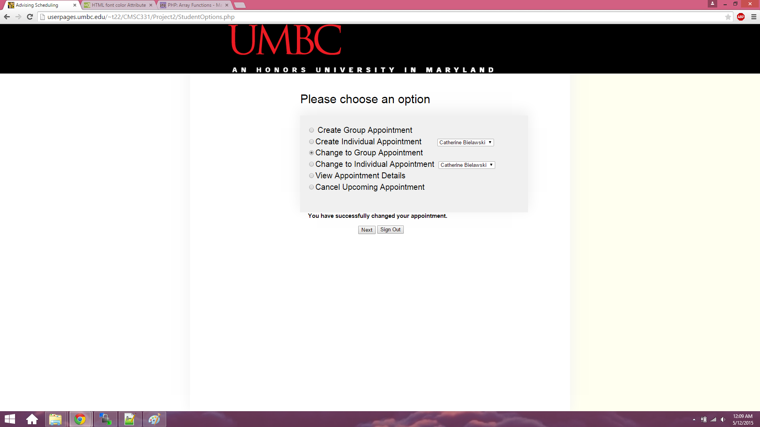

1. Student Changes to individual appointment

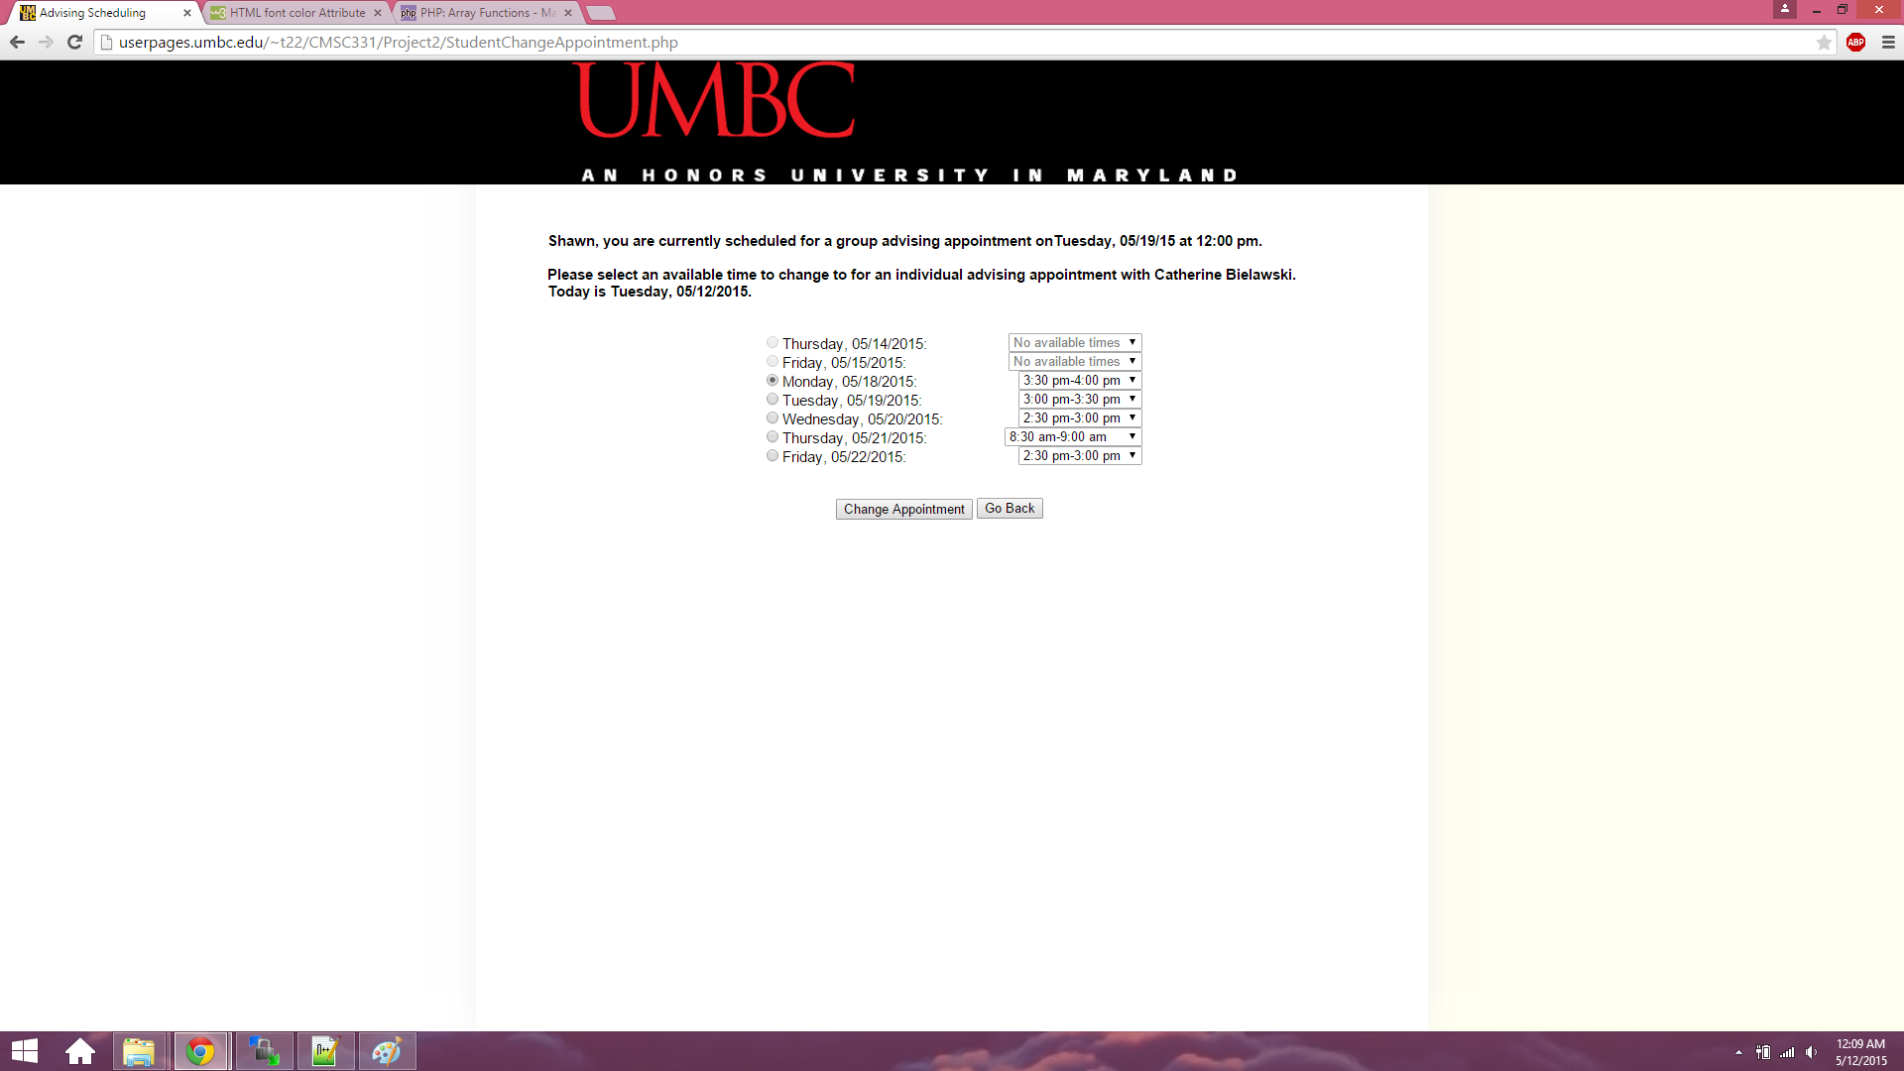

1. After student changes their appointment



1. Student views their appointment

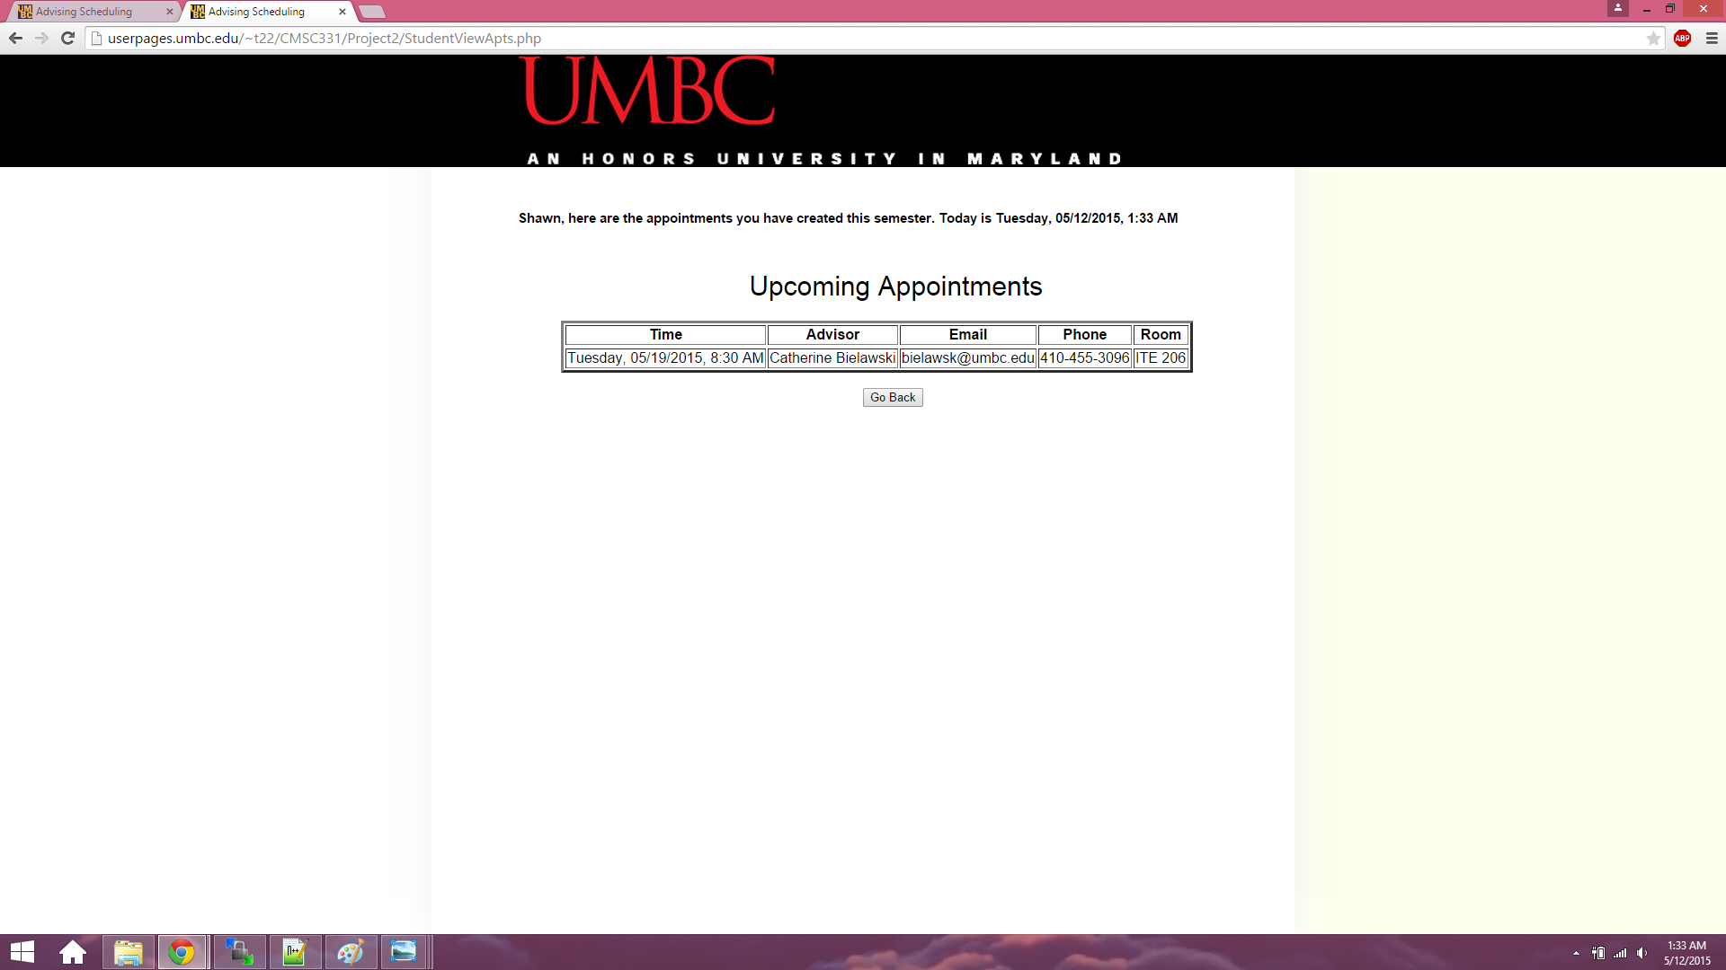

1. Student cancels appointment

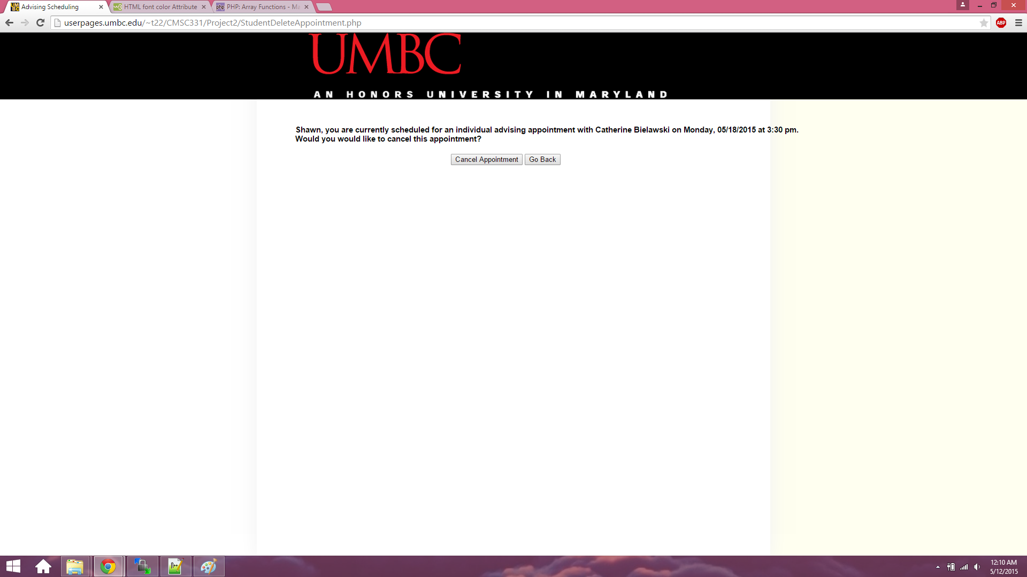

1. Student signs out



1. Advisor signin

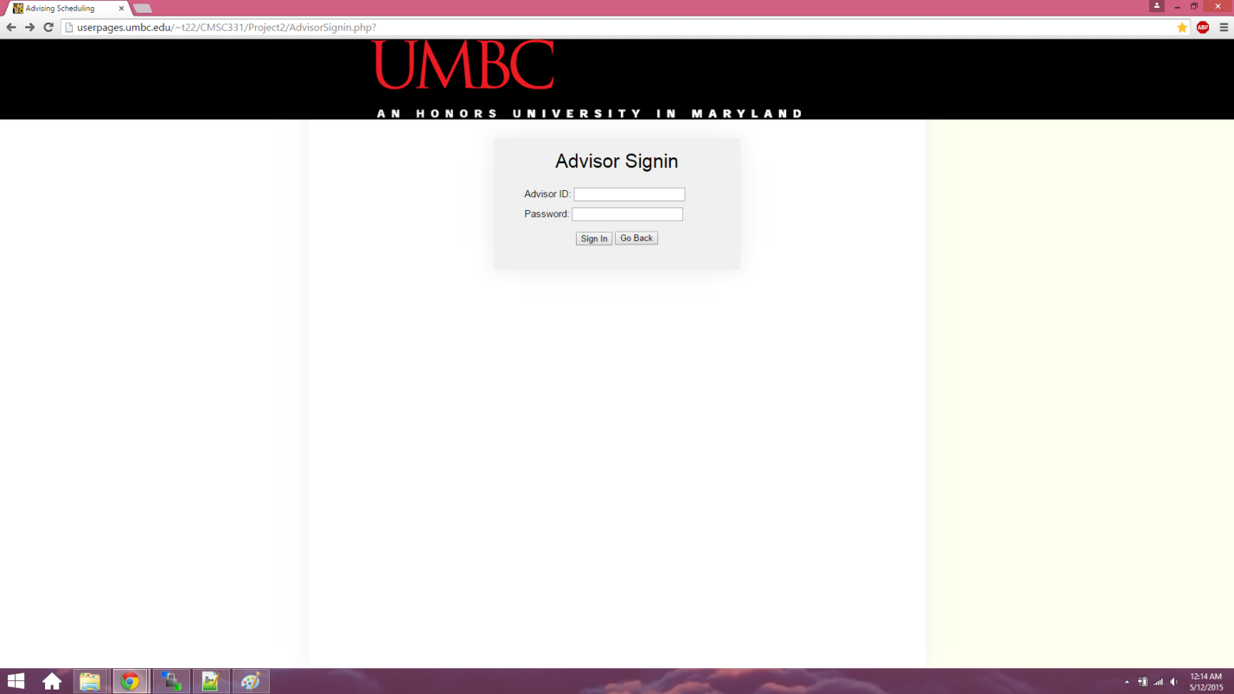

1. Advisor enters incorrect password

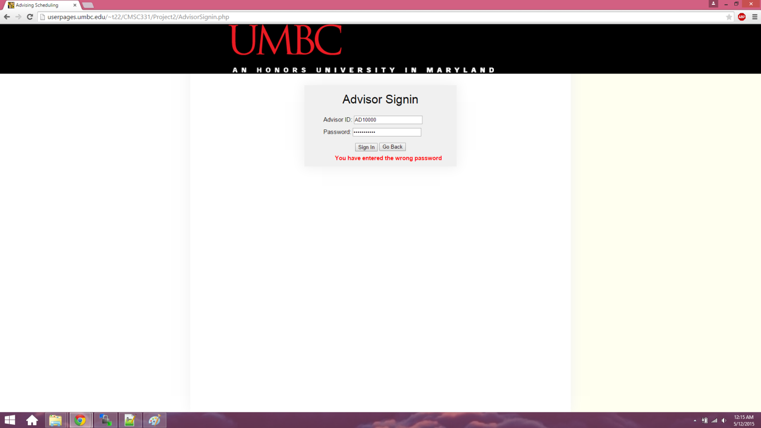

1. Advisor Options

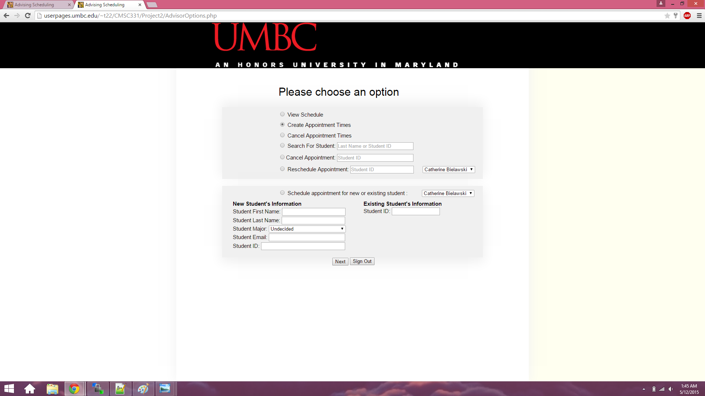

1. Advisor Create Appointment Times

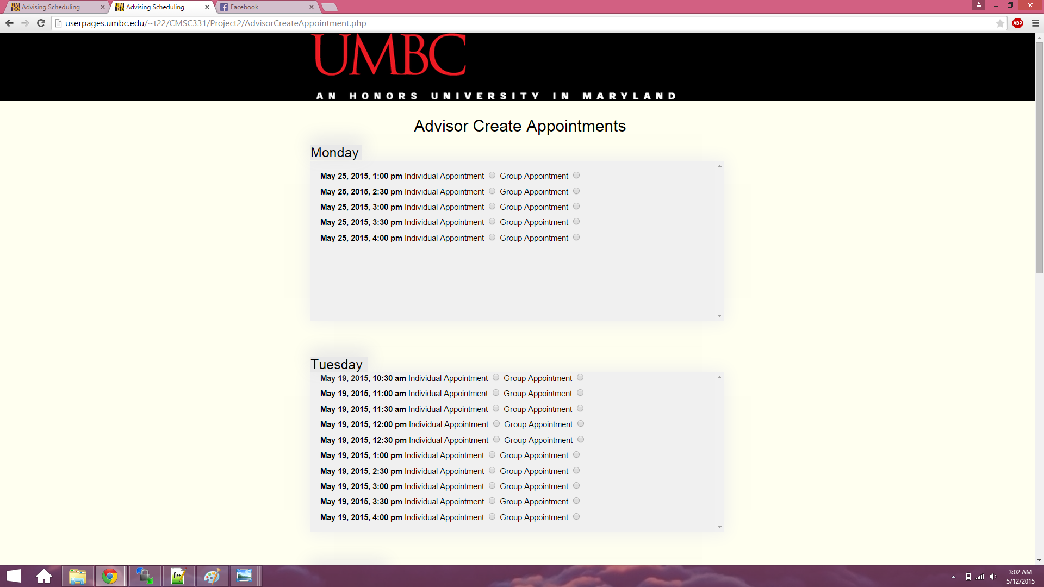

1. Advisor Searches for a Student

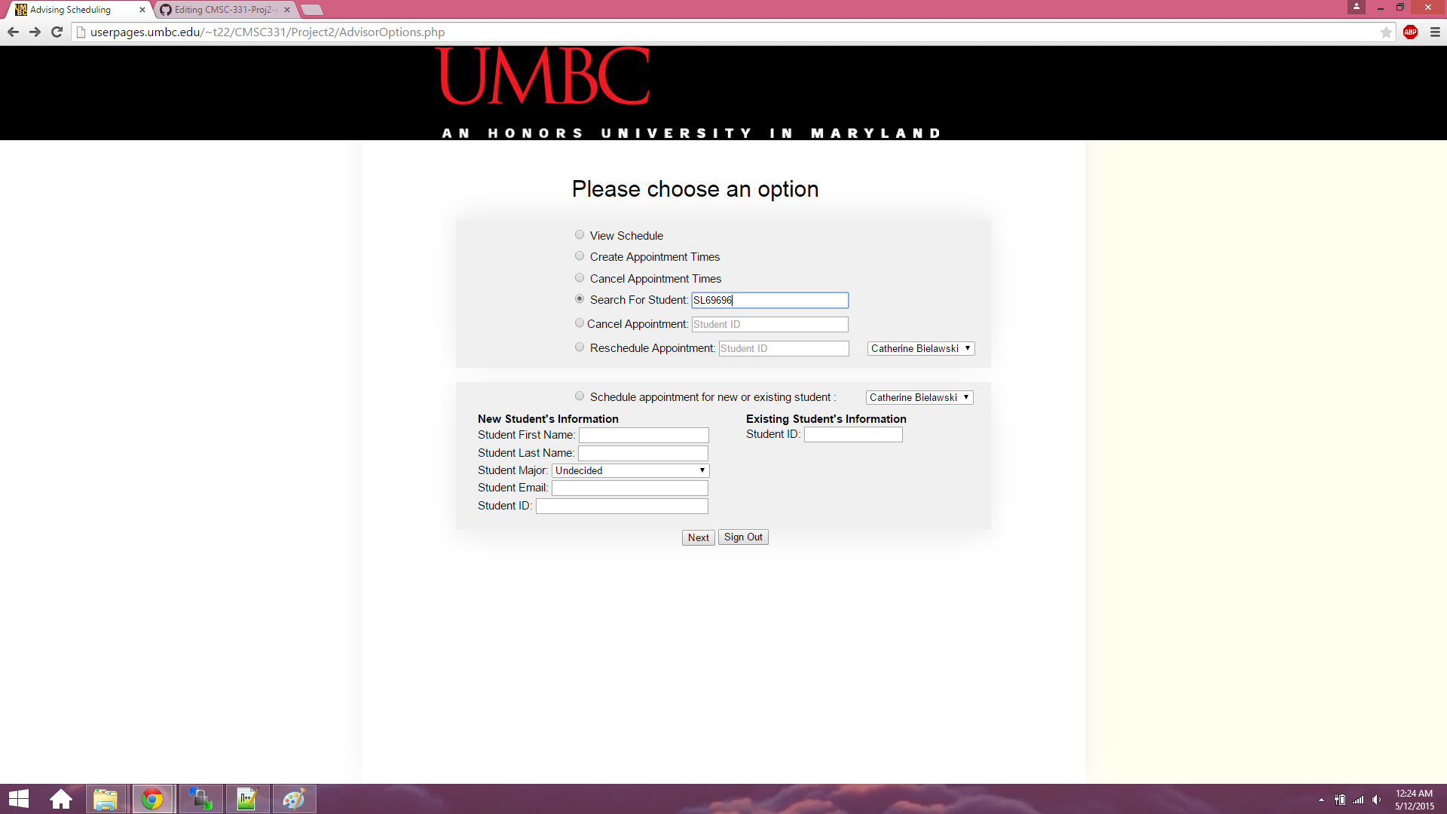

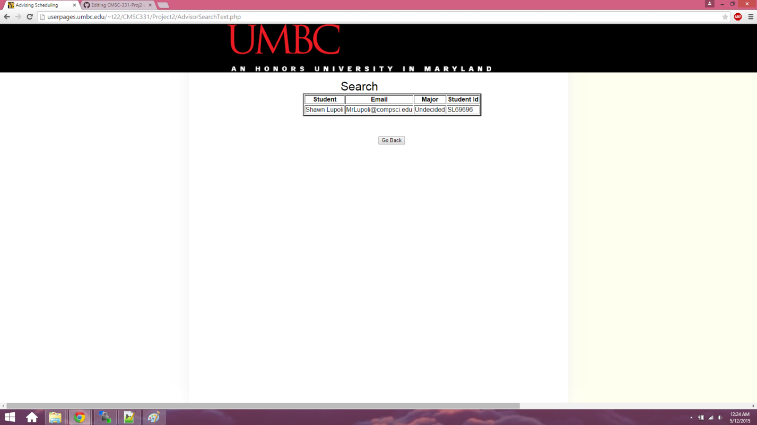

1. Advisor Cancels Appointment by Student Id

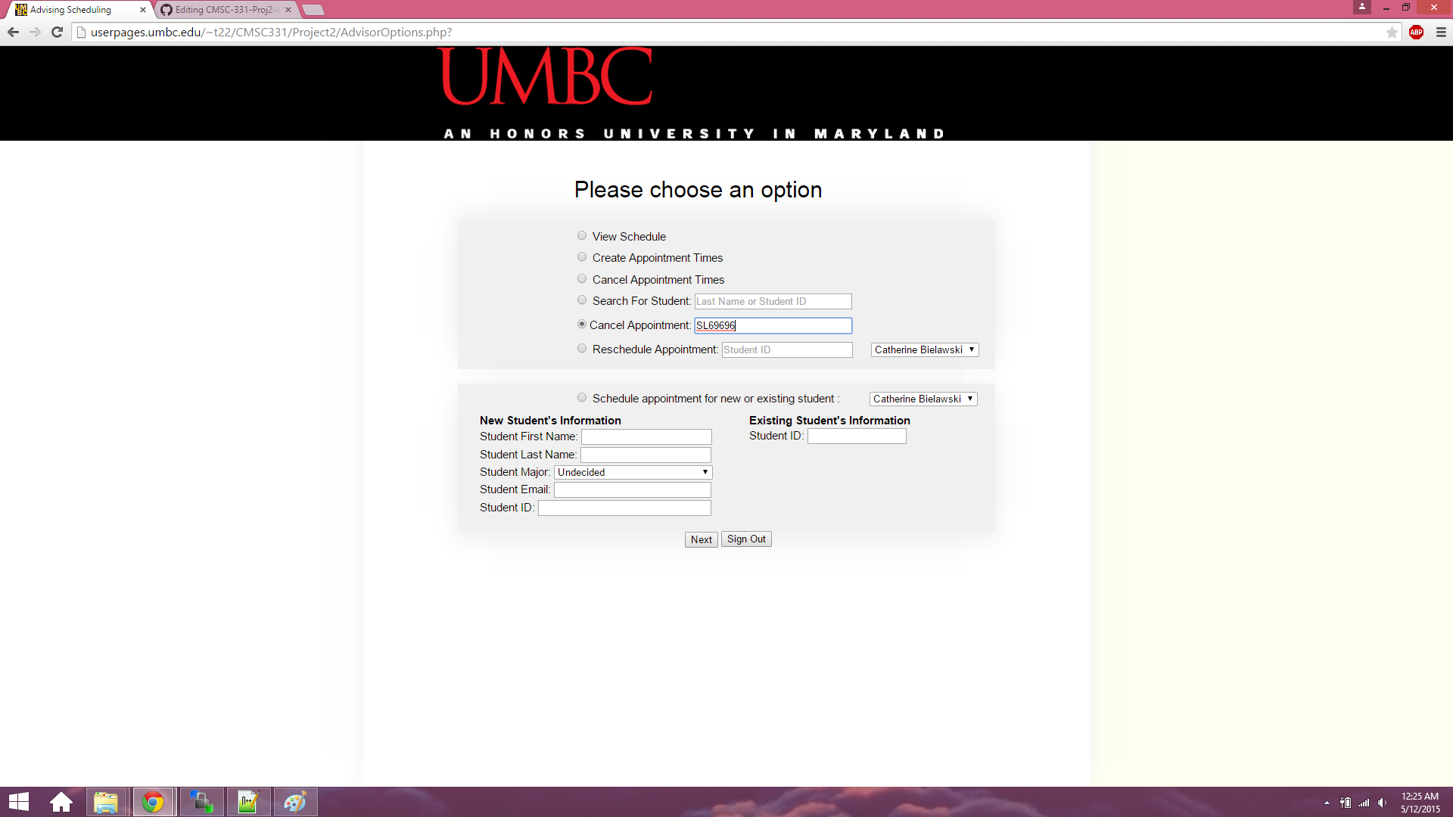

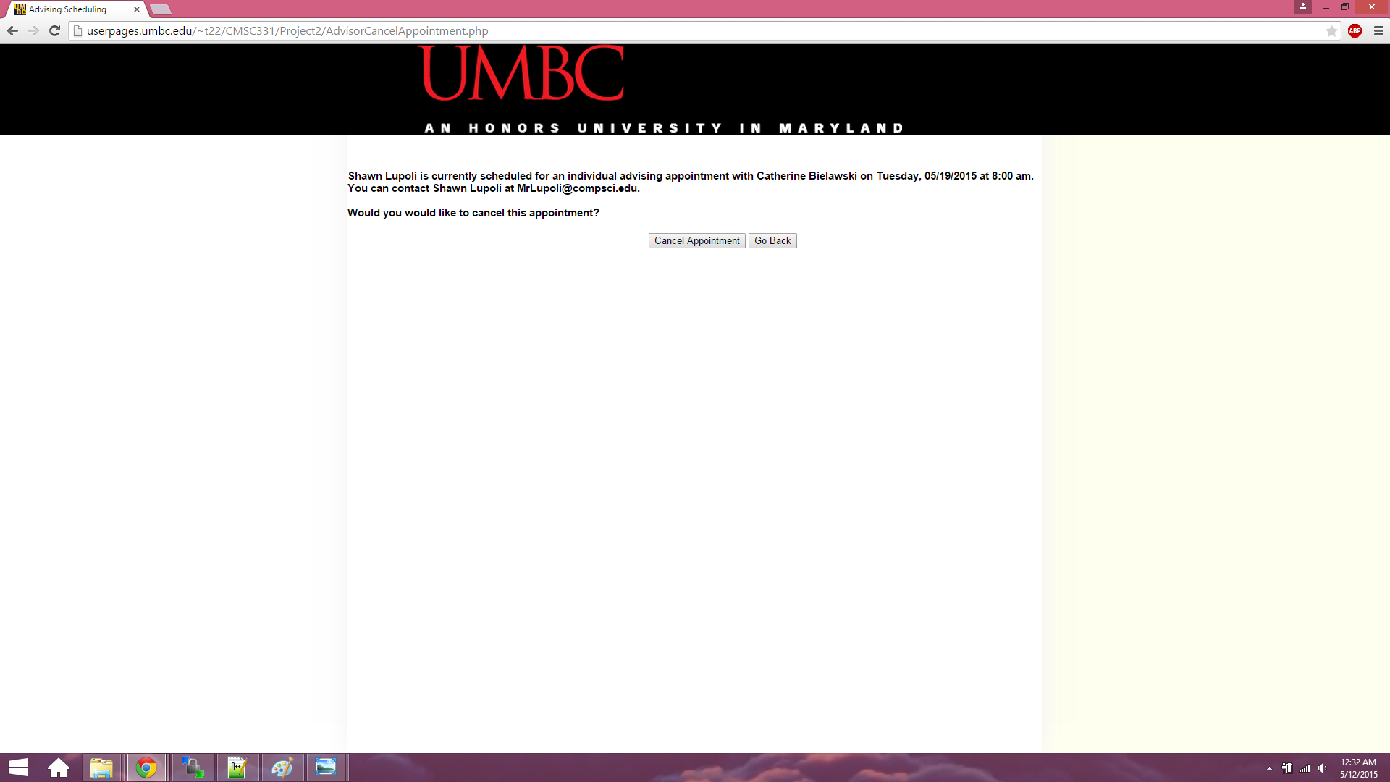

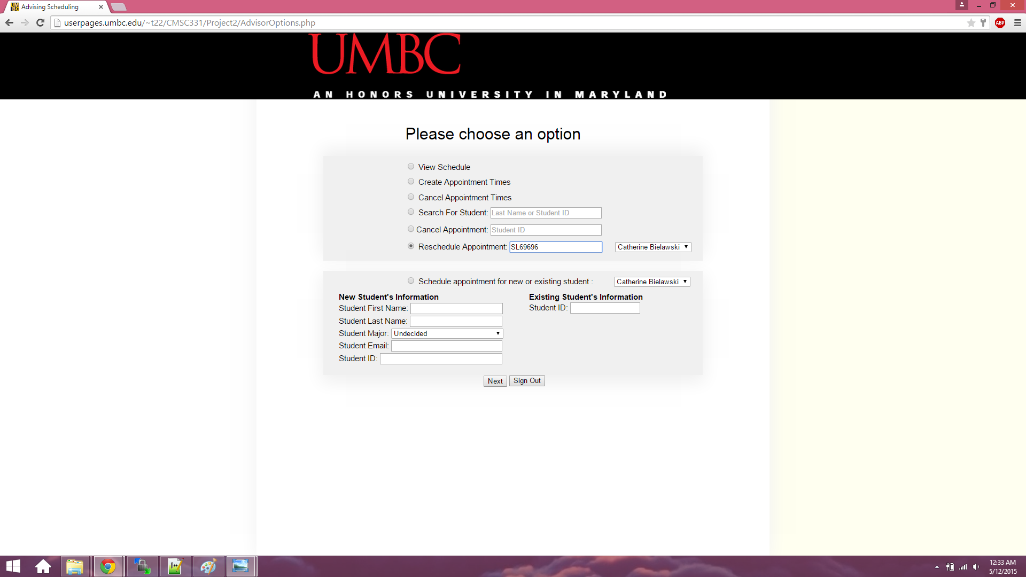

23 Advisor Reschedules the appointment

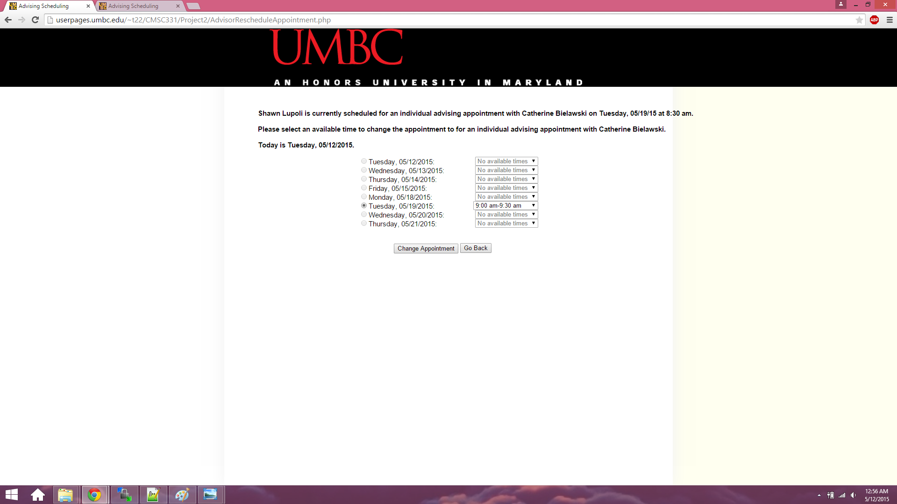

24 Advisor tries creating another appointment with same student

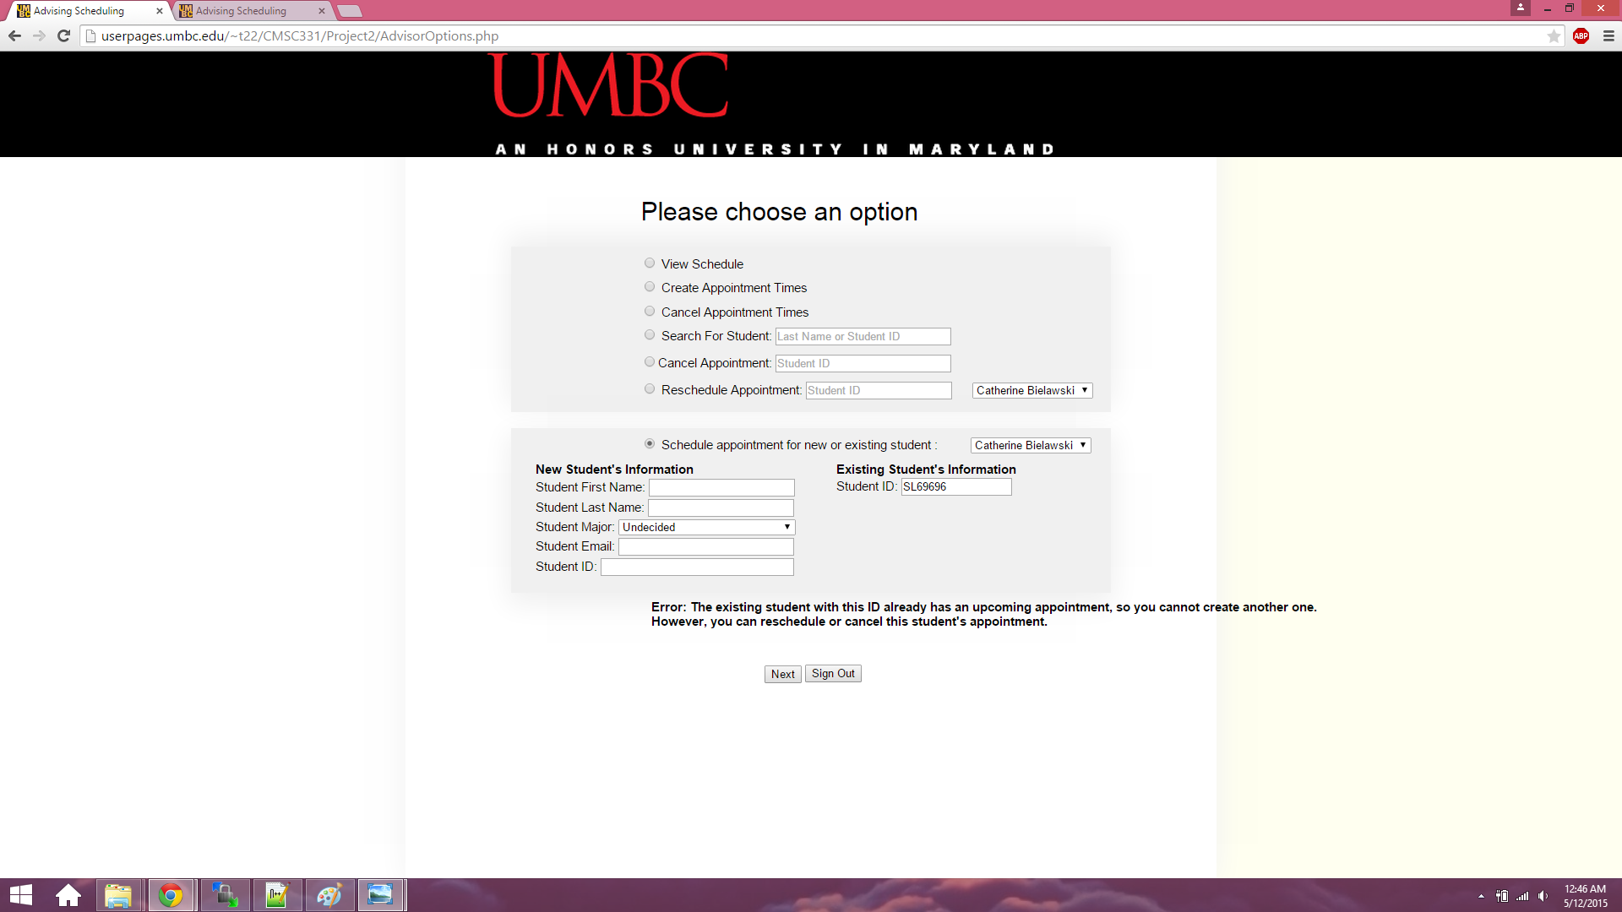

25 Advisor creates appointment with another student

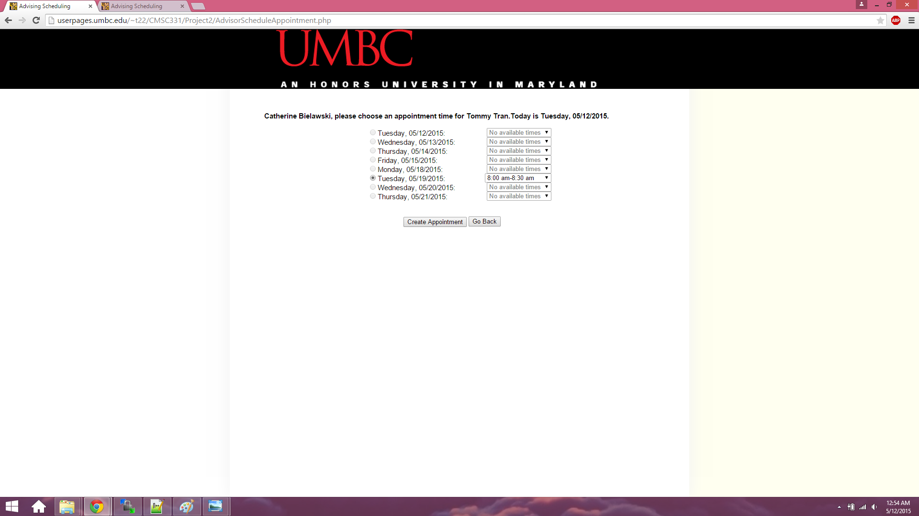

26. Advisor cancels that appointment time:

